**Name:** Yousef

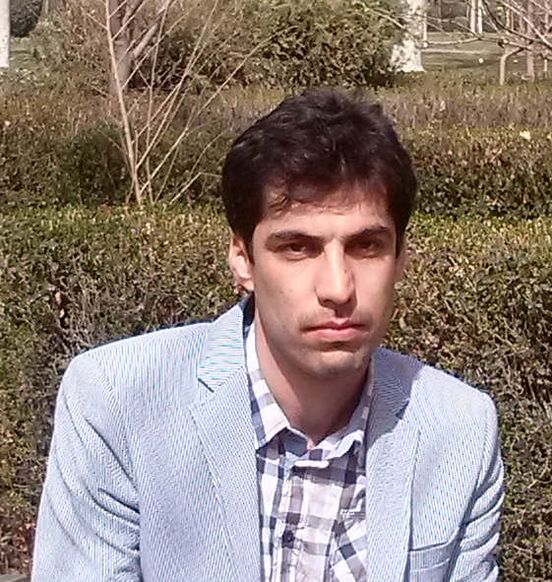

**Last name:** Mohamadi

**Degree:** PhD in anatomical sciences

**Sex:** male

**Birth date:** 1986.July.14

**Nationality:** Iranian

|  |  |
| --- | --- |
| **Contact Information** | Email: [yosef.1365@yahoo.com](mailto:yosef.1365@yahoo.com)  Academic email: [mohamadi-y@medilam.ac.ir](mailto:mohamadi-y@medilam.ac.ir)  mobile: +989102041429  Address: Ilam, Banganjab, Pajouhesh Blvd, Ilam University of Medical Sciences, Faculty of Medicine, Anatomy Department  Tel: +9884322325713; Fax: +988432227120; P.O.Box: 6939177143 |
| **Academic Rank** | Assistant Professor |
| **School** | Medicine |

**Education**

1. **B.Sc**

Technology of radiology, Iran University of Medical Sciences, Tehran, Iran, 2008

2. **MSc**

Anatomical sciences, Tehran University of Medical Science, Tehran, Iran, 2014

3. **Ph.D**

Health Policy, Tehran University of Medical Science, Tehran, Iran, 2018

**Ph.D Thesis**

**The effect of Wharton’s jelly mesenchymal stem cells on the inflammasome activity in animal model of spinal cord injury**

Supervised by Dr. Gholamreza Hassanzadeh, faculty member at Tehran University of medical sciences.

**Short Courses:**

|  |  |  |  |
| --- | --- | --- | --- |
| Year | Coordinator: | Location: | Course: |
|  |  |  |  |

**Current Position:**

* **Faculty member** of department of anatomy
* Working as the **Head of mentoring office of** medicine school
* Working as the **Head of advice office of** medicine school

**Experiences**



**Course Teaching**

1. **Anatomy, histology, embryology for medicine, paramedic, health sciences, nursing and dentistry students**

**Papers**

1. **English**

1. Salarinia R, Hosseini M, Mohamadi Y, Ghorbani A, Alamdari DH, Mafinezhad A, Sadeghnia H. Combined use of platelet-rich plasma and adipose tissue-derived mesenchymal stem cells shows a synergistic effect in experimental spinal cord injury. Journal of Chemical Neuroanatomy. 2020 Dec 1;110:101870.
2. Noori L, Arabzadeh S, Mohamadi Y, Mojaverrostami S, Mokhtari T, Akbari M, Hassanzadeh G. Intrathecal administration of the extracellular vesicles derived from human Wharton’s jelly stem cells inhibit inflammation and attenuate the activity of inflammasome complexes after spinal cord injury in rats. Neuroscience research. 2020 Jul 25.
3. Borhani-Haghighi M, Mohamadi Y. Intranasal administration of conditioned medium derived from mesenchymal stem cells-differentiated oligodendrocytes ameliorates experimental autoimmune encephalomyelitis. Journal of Chemical Neuroanatomy. 2020 Apr 27:101792.
4. Borhani-Haghighi M, Navid S, Mohamadi Y. The Therapeutic Potential of Conditioned Medium from Human Breast Milk Stem Cells in Treating Spinal Cord Injury. Asian Spine Journal. 2020 Apr;14(2):131.
5. Pourhanifeh MH, Mohammadi R, Noruzi S, Hosseini SA, Fanoudi S, Mohamadi Y, Hashemzehi M, Asemi Z, Mirzaei HR, Salarinia R, Mirzaei H. The role of fibromodulin in cancer pathogenesis: implications for diagnosis and therapy. Cancer cell international. 2019 Dec 1;19(1):157.
6. Mousavi M, Hedayatpour A, Mortezaee K, Mohamadi Y, Abolhassani F, Hassanzadeh G. Schwann cell transplantation exerts neuroprotective roles in rat model of spinal cord injury by combating inflammasome activation and improving motor recovery and remyelination. Metabolic brain disease. 2019 Aug 15;34(4):1117-30.
7. Borhani-Haghighi M, Mohamadi Y. The therapeutic effect of platelet-rich plasma on the experimental autoimmune encephalomyelitis mice. Journal of neuroimmunology. 2019 Aug 15;333:476958.
8. Borhani‐Haghighi M, Mohamadi Y, Kashani IR. In utero transplantation of neural stem cells ameliorates maternal inflammation‐induced prenatal white matter injury. Journal of cellular biochemistry. 2019 Aug;120(8):12785-95.
9. Mohamadi Y, Moghahi SM, Mousavi M, Borhani-Haghighi M, Abolhassani F, Kashani IR, Hassanzadeh G. Intrathecal transplantation of Wharton’s jelly mesenchymal stem cells suppresses the NLRP1 inflammasome in the rat model of spinal cord injury. Journal of chemical neuroanatomy. 2019 Apr 1;97:1-8
10. Mohamadi Y, Mousavi M, Khanbabaei H, Salarinia R, Javankiani S, Hassanzadeh G, Momeni F. The role of inflammasome complex in ischemia‐reperfusion injury. Journal of cellular biochemistry. 2018 Dec 13.
11. Borhani-Haghighi M, Kashani IR, Mohamadi Y, Pasbakhsh P. Embryonic intraventricular transplantation of neural stem cells augments inflammation-induced prenatal brain injury. Journal of chemical neuroanatomy. 2018 Dec 1;94:54-62.
12. Noruzi S, Azizian M, Mohammadi R, Hosseini SA, Rashidi B, Mohamadi Y, Nesaei A, Seiri P, Sahebkar A, Salarinia R, Aghdam AM. Micro‐RNAs as critical regulators of matrix metalloproteinases in cancer. Journal of cellular biochemistry. 2018 Nov;119(11):8694-712.
13. Hosseini SA, Mohammadi R, Noruzi S, Mohamadi Y, Azizian M, Mousavy SM, Ghasemi F, Hesari A, Sahebkar A, Salarinia R, Aghdam AM. Stem cell‐and gene‐based therapies as potential candidates in Alzheimer's therapy. Journal of Cellular Biochemistry. 2018 Nov;119(11):8723-36.
14. Mohamadi Y, Mousavi M, Moogahi SM, Abolhassani F, Ijaz S, Hassanzadeh G. Effect of Wharton's Jelly Derived Mesenchymal Stem Cells on the Expression of NLRP3 Receptor and Neuroinflammation in Experimental Spinal Cord Injury. Journal of Clinical & Diagnostic Research. 2018 Oct 1;12(10).
15. H Toolee, Y Mohamadi, Hypoplastic and Accessory Radial Arteries: A Case Report- Journal of Clinical & Diagnostic Research, 2018.
16. Gholaminejhad M, Arabzadeh S, Akbari M, Mohamadi Y, Hassanzadeh G. Anti-oxidative and neuroprotective effects of flaxseed on experimental unilateral spinal cord injury in rat. Journal of Contemporary Medical Sciences. 2017 Jun 26;3(10):213-7.
17. Mohamadi Y, Toolee H. Hassanzadeh Gh. Bilateral Variation of Internal Iliac Artery: A Case Study. Anatomical Sciences. 2017;14(1):57-60..
18. Mohamadi Y, Mousavi M, Pakzad R, Hassanzadeh G. Anthropometric parameters for access to sella turcica through the nostril. Journal of Craniofacial Surgery. 2016 Sep 1;27(6):e573-5.

2. **Farsi**

**Workshops:**

- Workshop of types of study designs

- Workshop of Consultant Master Regulations

**Skills**

* **Radiologic anatomy**
* **Histochemistry**
* **Immunohistochemistory**
* **TUNEL**
* **Western blotting**
* **Cell culture**
* **Scientific writing**
* **Statistics**
* **Endnote**

**Inventions**

**Language:**

* **English**
* **Farsi**

**Honors**

**Memberships**

**Research Interests:**

Anatomy

Neuroscience

Histology